***AUTUMN SHOW***

**Saturday 6th September 2014**

**2.30 pm to 4.30 pm**

***Howth and Sutton Horticultural Society***



**St Nessan’s Community School, Moyclare Road,**

**Off Warrenhouse Road, Baldoyle.**

**Admission to Show: € 2**

**Exhibitors & children (accompanied) - free**

**Members admitted free on production of current membership card**

**Wheelchair access to all parts of Show**

**Howth and Sutton Horticultural Society**

[**www.hshs.ie**](http://www.hshs.ie)

*Affiliated to the Royal Horticultural Society of Ireland*

*& North Dublin Horticultural Societies Association*

**MEMBERSHIP OF THE SOCIETY**

This Society is one of the longest established on Dublin’s northside having been founded in 1943.

The annual programme includes, when possible, a Spring Show in March/April, an Autumn Show in September, summer outings and a series of lectures by noted horticulturists in October, November, December, February and March.

**THE ANNUAL SUBSCRIPTION**

A vital source of revenue is the annual membership fee of €15.00, or €70.00 for a five year membership. If you have not already done so, please pay the annual subscription to Pauline Gavin, before or at the Show. (Membership runs from January to December)

Pauline Gavin, 48 Parkvale, Baldoyle, Dublin 13.

Phone 087 9817058

If you have e-mail, please forward your address to:

info@hshs.ie

*------------------------------------------------------------------------------------------------------*

*SHOW DISCOUNT:*

*New members joining at the Show - membership will cover the remainder of 2014 and also 2015*

__________________________________________________________________

**Committee for 2014**

President Máire Gorman

Honorary Chairperson Máire Gorman

Assistant Chairperson Lorna Hopkins

Honorary Secretary Ann Campbell

Assistant Secretary Helen Walsh

Hon. Treasurer Frances Marr

Assistant Treasurer June Ryan

Lecture Programme Rose Sevastopulo

Outings Manager Margaret Freyne

Media/Subs Pauline Gavin

Show Liasion Brigid McCaffrey

Publicity Mary Sheridan

~~~~~~~~~~~~~~~~~~~~~~~~~~~~~~~~~~~~~~~~~~~~~~~~

**VOLUNTEERS**

Volunteers are needed for the Show between 4 pm and 8 pm on the Friday afternoon to help set up tables for show classes, the plant sale, book sale and teas, mark out class spaces, place class numbers etc., and to help with clearing up after the Show on Saturday.

**If you can help, please give your name to a committee member**

**~~~~~~~~~~~~~~~~~~~~~~~~~~~~~~~~~~~~~~~~~~~~~~~~~~~**

**CURRENT CUP HOLDERS**

Current cup holders are requested to return cups to a committee member b*efore* the Show date.

**AUTUMN EVENTS/LECTURE SERIES**

**Wed. 1st Oct.**

***Starting a Garden in Howth- the story of Ardan*** - -

a talk by *our own members Conall O’Caoimh and Nuala Doherty*

Howth Yacht Club, 8.00pm

**Wed. 5th Nov**.

***Alpines at Home and Away* –**

T**alk** by Billy Moore, Churchtown. .

Howth Yacht Club, 8.00pm

**Wed. 3rd December:**

**The History and Flora of Lambay**

Social Evening with a talk by Matthew Jebb, Director of the National Botanic Gardens

&

**Supper** (please bring a cake or savouries). Mulled wine, tea & coffee provided.

Howth Yacht Club, 8.00pm

**Plant Exchange**:

At each lecture we encourage members to bring along a plant(s) for distribution amongst ourselves. Contributors get first choice. Surplus plants may be purchased for a small price. Leftovers will be nurtured for future plant stalls at the shows.

**A TRIBUTE TO PERCY LOVEGROVE**

Howth and Sutton Horticultural Society lost one of its most ardent members with the passing of Percy on June 15th 2014 at the great age of 93 years.

His association with the society goes back many years. He will be best remembered for his trojan work when, in the early 1980s, he obliged the then president, Mrs Meriel Latchford, and took on the role of chairperson. With his typical enthusiasm and great organisational skills and the backup of a willing committee, he brought new life into the society. He relished the celebrations to mark its Golden Jubilee in 1993, recorded for posterity on video. He was particularly proud of the associations with Pobalscoil Neassain, the new venue he found for the two annual shows and which we still use more than twenty years later.

Percy remained an active member of the society rarely missing a lecture or excursion, an intrepid exhibitor, and a vegetable judge, even at the last spring show. He was most generous with his time and always willing to pass on his extensive gardening knowledge. He liked nothing better than showing his beloved seaside garden in Sutton, a true testament to a great gardener.

J.M.J

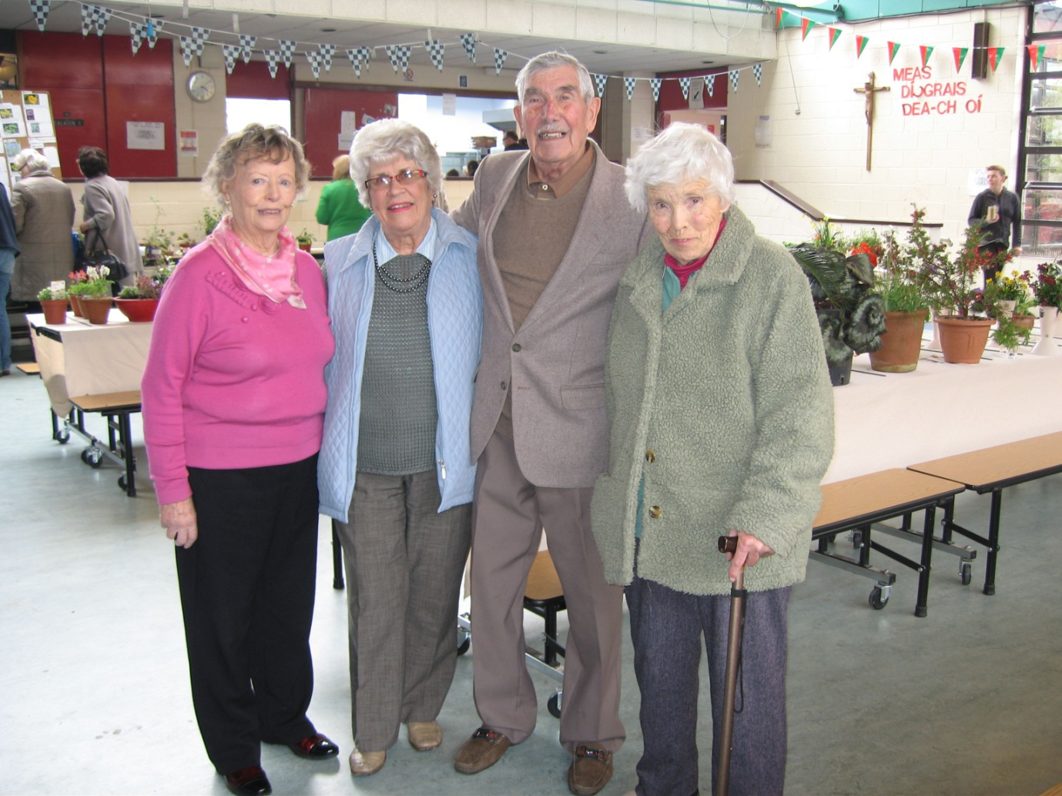Percy at the 2014 Spring Show with Maree O’Leary, Betty Pickering and Adrienne Cox

**SHOW RULES**

1. Entries should be made on the form provided at the back of the schedule.

**A separate entry form is to be used by each entrant.**

Entries should be mailed to, or telephoned to, or sent by e-mail to:

Ann Campbell, 34 Thormanby Lawns, Howth

(Telephone: 8394578; Email: [anncampbell@clonbrick.com](mailto:anncampbell@clonbrick.com)); or,

Rose Sevastopulo, 21 Evora Park, Howth.

(Telephone: 8324598; Email: rose.sevastopulo@gmail.com)

**Entries** close on Thursday 4th September.

2. Exhibitors are restricted to **1** entry per class. Two or more persons may not exhibit separately in the same class material from the same garden or plant house.

3**. Exhibits may be brought to the school from 5pm on Friday and should be staged** between **5.30 and 8.00 pm** on Friday or between **8.30 and 11.00 a**m on Saturday. **Exhibitors must leave the hall by 11.00 am**.

4**. Judging** will commence at **11.30 am.**

5. Maximum size of pots is the maximum external diameter.

6. The term ‘distinct’ refers to distinct species, varieties, forms or cultivars.

7. The Committee reserves the right to remove from display exhibits considered to be sub-standard. The Committee will not be held liable for loss of, or damage to, exhibits.

8. The Judges’ decision is final. Judges are empowered to withhold awards if the standard of exhibits in any section is not satisfactory.

9**.** Horticultural Exhibits should be named, where possible, withthe name of the plant (species, cultivar, etc.).Labels should be written in capital letters and should be oriented horizontally. Exhibitors may obtain white card labels and butchers’ pins at the show. Between exhibits of equal merit in the horticultural classes, **clear correct naming** shall be the deciding factor.

10. Where cups are awarded for aggregate points, each first prize will count three points; each second, two points; and each third, one point. In the event of a tie, the exhibitor with the greater number of first prizes will be declared the winner.

11. Exhibits and class cards should not be removed by exhibitors until the show is

over. Class prizes will be determined from class points lists.

**VASES**

Vases will be available at the show.

**PRIZES**

Prizes will be awarded only in the Junior section. There is no entry fee in any class.

**Class Alpine, Bonsai, Cacti and Succulents**

1. **Hardy Rock Plant,** 1 in pot/pan, not exceeding 32 cm in outside diameter
2. **Bowl of Cut Flowers** of Rock plants (including dwarf shrubs) Arrangements not to exceed 30 cm. wide or 25 cm. in height
3. **Cactus or Succulent** in bloom
4. **Bonsai** or **Dwarf Conifer**, 1 plant in pot or pan
5. **Cacti**, 3 pots or pans, each a different variety, one plant in each pot
6. **Cactus**, 1 pot or pan
7. **Succulents**, other than Cacti, 3 pots or pans, each different
8. **Succulen**t, other than Cactus, 1 pot or pan
9. **Cacti or other Succulents**, 3 pots not exceeding 10 cm in outside diameter, each a different variety
10. **Cacti and/or Succulent** **Display** for a patio in a container not exceeding 40 cm. in length or width

**Rose classes**

1. Roses, Large Flowered, vase of 3 blooms, each different
2. Roses, Large Flowered, vase of 3 blooms, one variety
3. Rose, Large Flowered, 1 bloom
4. Roses, vase of 3 blooms to be judged on fragrance
5. Roses, Cluster Flowered, 2 vases, each of 1 variety, 3 stems in each
6. Rose, Cluster Flowered, 1 stem
7. Rose, Climbing, 1 piece of branch not to exceed 60 cm. in length

18. Miniature/Patio Rose in pot

**Auverne Perpetual Cup**

awarded to the winner of class 5.

Holder: Christopher White

**Mrs E M Russell Cup**

awarded to the Member with the highest number of points in classes 5 – 10.

Holder: Christopher White

**The Norah Mathews Perpetual Cup**

awarded for the most meritorious exhibit in classes 11 – 13.

Holder: John Warren

**J Bramwell Smith Perpetual Cup**

awarded to the exhibitor gaining the highest number of points in classes 11 – 18.

Holder: Rachel Naughton

**Flowers**

**Class**

1. **Sweet Pea**, vase of 6 stems, may be mixed
2. **Tuberous Begonias**, double, 3 blooms, may be mixed
3. **Tuberous Begonias**, outdoor, 3 blooms, may be mixed
4. **Hardy Geranium**s, vase of 3 blooms, may be mixed
5. **Carnations**, outdoor, vase of 3 blooms, may be mixed
6. **Violas**, 5 blooms, may be mixed
7. **Pansie**s, 5 blooms, may be mixed
8. **Asters**, double, vase of 5 blooms, may be mixed
9. **Asters**, single, vase of 5 blooms, may be mixed.
10. **Annual**, 1 vase of one species, excluding aster/sweetpea
11. **Heleniums**, 1 vase of three stems
12. **Cut Flowers**, 2 vases, a different variety in each.
13. **Vase of Cut Flowers**, may be mixed. Confined to exhibitors who have not won a first prize for Cut Flowers at a previous Howth & Sutton Horticultural Show
14. **Hardy Herbaceous Flowers**, 2 vases, one distinct species in each vase. *All varieties must be named*. This class will be judged on points (see below)

Quality and freshness: 40

Interest, variety and novelty: 25

Arrangement and general effect: 25

Correct naming: 10

1. **Hydrangea hortensis (Mophead),** 1 vase, 3 blooms, may be mixed
2. **Any other Hydrangea**, 1 vase, 3 blooms, may be mixed
3. **Hydrangea**, 1 bloom
4. **Hardy Herbaceous Flowers**, 1 vase of one variety
5. **Shrub Flower,** other than Hydrangea, 1 vase, 1 variety
6. **Any Berried Shrub**, portion of branch not to exceed 45 cm in length
7. **Michaelmas Daisies**, vase of 3 stems, may be mixed
8. **Gladiolus**, 1 spike, large flowered
9. **Gladiolus**, vase of 3 spikes, large flowered, may be mixed
10. **Gladiolus**, vase of 3 spikes, one or more varieties other than large flowered (e.g. Primulinus)
11. **Dahlias, decorative,** 1 vase, 3 blooms
12. **Dahlias, Cactus or Semi-cactus**, 1 vase, 3 blooms
13. **Dahlias, Pompom**, 1 vase, 3 blooms, flowers fully double, almost round in shape with tightly quilled petals. Flower size not to exceed 52mm in diameter.
14. **Dahlias**, 3 blooms not provided for in previous classes

**Stanley J Land Memorial Perpetual Trophy**

awarded to the **member** who gains the highest number of points in classes 19 – 30

Holder: Phyllis Owens

**St Lawrence Perpetual Cup**

will be awarded to the winner of class 32.

Holder: Brian Lynch

**Colonel Woods Perpetual Cup**

awarded for the best exhibit of Gladiolus in classes 40,41,42.

Holder: John Warren

**Colonel J G Woods Perpetual Cup**

awarded for the best exhibit of dahlias in classes 43 - 46

Holder: Pat Thornton

**Pot plants**

**Class**

1. **Pelargoniu**m, in a pot not to exceed 20 cm in maximum diameter
2. **Pelargoniums in flower**, 3 distinct in pots, not to exceed 20 cm in maximum diameter
3. **Pot plant,** 1 plant in a pot, any cool greenhouse or house plant in bloom not otherwise provided for
4. **Pot plant**, any greenhouse or house plant, other than Pelargonium, in pot not exceeding 10 cm maximum diameter
5. **Pot plant**, not necessarily in bloom, to be judged for foliage effect
6. **Fuchsia**, in a pot
7. **Fern**, in a pot
8. **Hanging basket**, ornamental
9. **A container**, planted for effect with two or more plants, maximum dimension 40 cm x 40 cm
10. **Any unusual plant**
11. *Orchids i*n bloom, one or more plants of the same variety in a pot

**Florence Griffin Perpetual Trophy**

awarded to the winner of first prize in class 50.

Holder: Madeleine Harford

**Violet Jameson Perpetual Cup**

To be awarded for most outstanding exhibit in classes 49 - 59

Holder: Madeleine Harford

**Fruit**

**Class**

1. **Pears**, dish of 5, one named variety
2. **Plums,** dessert, dish of 9
3. **Rhubarb**, 3 sticks
4. **Apples, cooking,** dish of 5, any one variety
5. **Apples, dessert**, dish of 5, any one variety
6. **Grapes,** 1 bunch
7. **Dish of any other fruit**

**Flower, plant and vegetable collections**

1. 1. Two vases of cut flowers, may be mixed

2. Two pot plants

3. Two vegetables, not more than three of each kind, or two fruit, two distinct kinds, not more than five of each kind

70. A gourmet collection to comprise any 3 of the following, variety to be named: 1 lettuce, 3 courgettes, 5 mangetout or sugarsnap peas, 1 bouquet garni (bunched ready for use), 1 dish cherry tomatoes, 1 dish edible flowers

71 A collection of vegetables, not exceeding 5 kinds, selected from the following: cabbage 1 head; lettuce 1 head; onions 3 bulbs; beetroot 3 roots; peas 6 pods; French beans 6 pods; runner beans 6 pods; broad beans 6 pods; potatoes 3 tubers; carrots 3 roots; cauliflower 1 head; celery 1 head; sweet corn 1 cob; vegetable marrow 1. Space allowed – 100 cm x 100 cm

**D Mullin Memorial Perpetual Trophy**

awarded to the winner with the highest number of points in classes 62 – 68

Holders: John Harford

**Dr Michael Woods Golden Jubilee Trophy**: awarded to the winner of class 69

Holder: Ann O’Meara

**The Douglas Mellon Perpetual Cup**: awarded to winner of class 71

Holder: Sean Brady

**Vegetables**

**Class**

1. **Cucumber**, 2 fruits
2. **Tomatoes**, dish of 5, with stems, one variety named
3. **Tomatoes**, 1 truss, as cut from plant, ripeness to count
4. **Tomatoes**, 1 truss of small fruited variety
5. **Cabbage**, ~~2~~ 1 heads
6. **Cauliflower**, ~~2~~ 1 heads
7. **Carrots**, 3 stump-rooted
8. **Carrots**, 3 long-rooted
9. **Beetroot**, 3 roots
10. **Lettuce**, 1 head
11. **Peas**, 6 pods
12. **French Beans**, dwarf or climbing, 6 pods
13. **Runner Beans**, 6 pods
14. **One Runner Bean**, longest pod, judged by length only
15. **Pumpkin**, largest, to be judged by weight
16. **Turnips**, White or Orange Jelly, 3 roots
17. **Parsley**, bunch of 6 stalks
18. **Culinary Herbs**, 3 vases, each different (excluding parsley)
19. **Vegetable Marrow**, 1
20. **Courgettes**, 3
21. **Vegetable Marrow**, largest, to be judged by weight
22. **Parsnips,** 3 roots
23. **Potatoes**, 5 tubers of any variety
24. **Onion**s, 5 of any variety (excluding sets)
25. **Onions**, 5 sets only
26. **Shallots**, 10
27. **Dish of any other vegetable**

**Armstrong Perpetual Cup**

awarded to the **member** gaining the highest number of points in classes 72 – 98

Holder: *John Warren*

**PHOTOGRAPHY**

**Class**

104. A close up photograph of a flower, animal or bird, **mounted, titled, but not framed**. Photograph no larger than 7” x 5”/13 cm x 18 cm.

105. Any photograph of horticultural interest, **mounted, titled, but not framed**. Photograph no larger than. 7” x 5”/13 cm x 18 cm

106. A photograph of a Garden, Park-land, Seascape, General Scenery, **mounted, titled, but not framed**. Photograph no larger than 7” x 5”/13 cm x 18 cm.

**Please write your name and class no. on back of photographs**

**ART**

**Class**

107. **Painting**, water colour

108. **Painting**, oil

109. **Picture** in any other medium

110. **A drawing or sketch**

**CRAFTS**

**Class**

112 **Any handcrafted article** excluding woodwork

113 **Any handcrafted article made of wood**

**Latchford Trophy**

awarded to the most outstanding exhibit in classes 104 - 113

Holder: Florence Campbell

**COOKERY**

**Class**

1. Chutney (1 pot), date made to be stated
2. Brown/White yeast bread
3. White Soda Bread
4. Brown Soda Bread
5. Tea Scones (6)
6. Tea Brack
7. Light Fruit Cake made according to recipe (see following page)
8. Victoria Sandwich Cake (filled and iced on top only)
9. Vegetarian bake, e.g. tart, quiche, pizza, etc.
10. Chocolate Cake (iced and decorated)
11. Madeira Cake
12. Mince Pies (6)
13. Biscuits, undecorated (6)
14. Raspberry, Tayberry or Loganberry Jam (1 pot)
15. Strawberry Jam (1 pot)
16. Marmalade, fresh fruit (1 pot)
17. Jelly (1 pot)
18. Blackcurrant Jam (1 pot)
19. Any jam other than in classes 138 – 142

**No member of the Bakery and Confectionery Trade may exhibit**

**Desmond Bell Cup**

awarded to the exhibitor gaining the highest number of points in classes 125 – 143 Holder: *Ann Coulter*

j0215779

**Light Fruit Cake Recipe (Class 131)**

**Ingredients:**

5oz/150g butter at room temperature

5oz/150g caster sugar

3 large eggs

8 oz/225g plain flour, sifted together with baking powder

1 teaspoon baking powder

6oz/175g currants

6oz/175g sultanas

2 oz/50g glace cherries, rinsed, dried and cut into halves

2 oz/50g mixed whole candied peel, finely chopped

2 Tablespoons ground almonds

The grated rinds of 1 small orange and 1 small lemon

2 oz/50g whole blanched almonds

A 7-8”/18-20cm round tin, lined with baking parchment.

**Preheat the oven to gas mark 3, 325oF, 170oC, 160oC for fan oven**

#### Method:- In a mixing bowl beat butter and sugar together until light and fluffy. In a separate bowl whisk the eggs, then, a little at a time, beat them into the creamed butter and sugar, adding a dessertspoon of flour each time. Carefully fold in the remainder of the flour. The mixture needs to be of a good soft dropping consistency. If it seems too dry, add a dessertspoon of milk.

Carefully fold in the fruit, ground almonds, and orange and lemon rinds. Then spoon the mixture into the prepared cake tin, smoothing it out evenly with the back of the spoon. Next arrange the whole almonds in circles on top of the mixture, but do this carefully and lightly; if they are pressed in they will sink during the baking.

Place the cake in the centre of the oven and bake 2 – 2 1/2 hours or until the centre is firm and springy to the touch. Let it cool before taking it out of the tin. This cake keeps very well in an airtight tin and tastes all the better if kept for a few days before cutting.

**JUNIOR SECTION**

***Entries in the Junior section to be the exhibitors’ own unaided work.***

***Only one entry per person is allowed in any one class***

***Age on day of Show to be stated on back of all class cards***

**Children under 8 years (on the day of the Show)**

**Class**

1. **A bunch of flowers in a jam jar**
2. **A biscuit decorated as a face**
3. **A painting or drawing,** subject of your own choice – any size up to A3 (42cm x 30cm)
4. **A collage of a bird** on A4 sheet (21cm x 30cm)
5. **Something I have made** – an article from natural materials, e.g. sea shells, plant material, feathers, etc. (not from a kit)

**Children 8 years and under 15 years (on the day of the Show)**

**Class**

1. **A novelty cake**
2. **A bunch of wild flowers in a tea cup**
3. **A collage of a fish** on A4 sheet (21cm x 30cm)
4. **The best photograph I have taken** – mounted, titled but not framed . Photograph no larger than 7” x 5”/13 cm x 18 cm.
5. **A painting or drawing with an Autumn theme,** any size up to A3 (42cm x 30cm)
6. **A garden Gnome** based on a 1 litre milk carton and any natural material
7. **A miniature garden** in a seed tray (or container approximate size 36cm x 22cm)

***AGE WILL BE TAKEN INTO CONSIDERATION IN ALL CHILDREN’S***

***CLASSES***

Amount enclosed: € …..

Howth & Sutton Horticultural Society

**Membership/Renewals Form**

Membership subscriptions are due on 1st January each year

I wish to renew my membership of the HSHS for the year ending 31st December 2014 and I enclose my subscription of €15 for one year to 31st December 2014 or €70 for five years to 31st December 2019..

New Membership ..... .. or Renewal Membership ....... [*please tick*]

**Rates are as follows**:

€15 : Family membership €70 : membership for 5 years

Name: .......................................................................................

Address:.................................................................................................

...................................................................................................

Telephone: ......................... Mobile:..................................

Email: ......................................................................................

Cheques should be made payable to Howth and Sutton Horticultural Society and forwarded with this membership Form to:

Pauline Gavin, 48 Parkvale, Baldoyle, Dublin 13.

**The North Dublin Horticultural Societies Association**

**The ‘Exhibitor of the Year’ Perpetual Trophies**

**The ‘Exhibitor of the Year’ Perpetual Trophies** will be competed for at The North Dublin Horticultural Societies Association Annual Summer Shows.

The Trophies will be awarded to the exhibitors who obtain the highest total number of points at all ten Shows (or as many as exhibited in) at the open horticultural classes in two categories –

**(A) Cut Flowers and Pot Plants (B) Fruit and Vegetables**

Points will be determined on the basis of 3, 2, 1, for 1st, 2nd and 3rd respectively.

The names of the ten exhibitors obtaining the highest points in each of the two categories at each Show will be sent to the Association for inclusion in this competition.

The NDHSA Trophies will be presented at the **‘End of Season Show’** hosted by **Rush** on **11th October** in **St. Maur’s GAA Club.**

**North Dublin Show dates for 2014**

|  |  |  |
| --- | --- | --- |
|  |  |  |
| **26th & 27th July\*** | **Malahide** | **8453947** |
| **2nd August\*** | **Cameron** | **8480538** |
| **4th August\*** | **Fingal (Swords)** | **086 3343680** |
| **16th & 17th August\*** | **Dublin 5 - Vista Show** | **8473559** |
| **31st August\*** | **St. Brigid's** | **8342140** |
| **6th September\*** | **Howth & Sutton** | **8324598** |
| **7th September\*** | **Balbriggan** | **087 7520506** |
| **13th & 14th September\*** | **Naul** | **8413494** |
| **21st September\*** | **Clontarf** | **087 988 6177** |

**The Society wishes to express sincere thanks to the Principal and the staff of Pobalscoil Neasáin and to Howth Yacht Club for their co-operation and assistance in its various activities.**

~~~~~~~~~~~~~~~~~~~~~~~~~~~~~~~~~~~~~~~~~~~~~~~~~~

**The Committee is grateful to the following firms whose generous donations of special prizes are greatly appreciated .**

***Please support them whenever possible***

**Main Street Flowers & Country Market, Howth**

**McDermotts Pharmacy, Howth**

**Whelehans of Finglas**

**Howth Garden Centre**

**Howth & Sutton Horticultural Society**

# Entry Form for Autumn Show 2014

Entries close on Thursday before show, 4th September 2014

Exhibits to be staged between 5.00pm and 8.00pm on Friday night

or between 8.30am and 11.00am on the morning of the show*.*

*I give notice that I intend to exhibit in the classes detailed below.*

*I will conform with the rules and regulations in the Show Schedule.   
 I fully understand that I may not remove my entries or class cards*

*before 4.30pm. I declare that my entries will be my own production*.

Signed………………………………… Tel…………………

## CLASS NUMBERS

|  |  |  |  |  |  |  |  |  |  |
| --- | --- | --- | --- | --- | --- | --- | --- | --- | --- |
|  |  |  |  |  |  |  |  |  |  |
|  |  |  |  |  |  |  |  |  |  |
|  |  |  |  |  |  |  |  |  |  |

Name (capitals)………………………………. Age (child only)…….

Address………………………………………………………..

………………………………………………………..

Please state if you have paid your 2014 membership ………

**Please send your entries to *either***

1. Ann Campbell , 34 Thormanby Lawns, Howth  
   Tel: 8394578 Email: [Anncampbell@clonbrick.com](mailto:Anncampbell@clonbrick.com)
2. Rose Sevastopulo , 21 Evora Park, Howth  
   Tel: 8324598 Email: [rose.sevastopulo@gmail.com](mailto:rose.sevastopulo@gmail.com)

**PLANT SALE**

Please propagate for the plant stall. It is becoming increasingly difficult to source unusual plants or even old favourites. We need to increase our range of ‘well presented, named plants’ for the many eager buyers. Contributions can be left at the school on Friday 5th September, between 4 pm and 6.45 pm, or as early as possible on the Saturday morning.

**BOOK SALE**

If you have unwanted books, magazines, CDs or DVDs in good condition, please give them to the book stall. They will be gratefully accepted.

**(Location Map)**

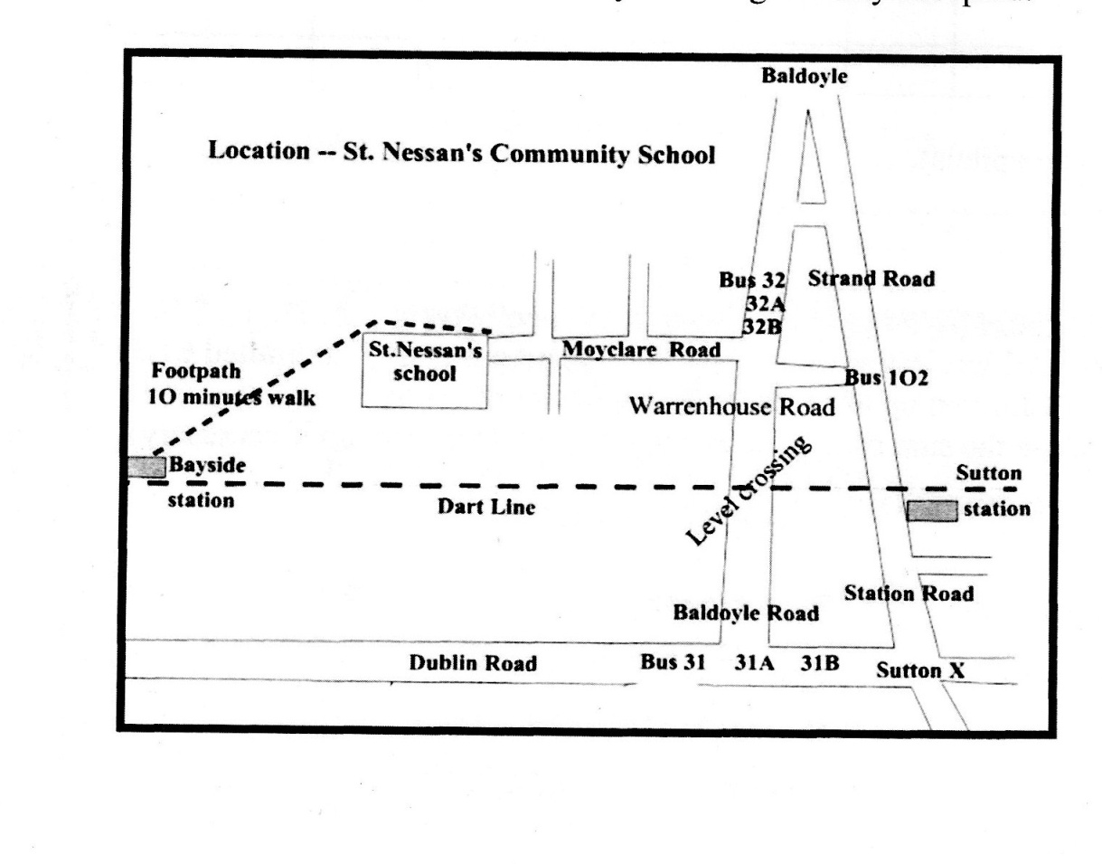

***Howth and Sutton Horticultural Society***

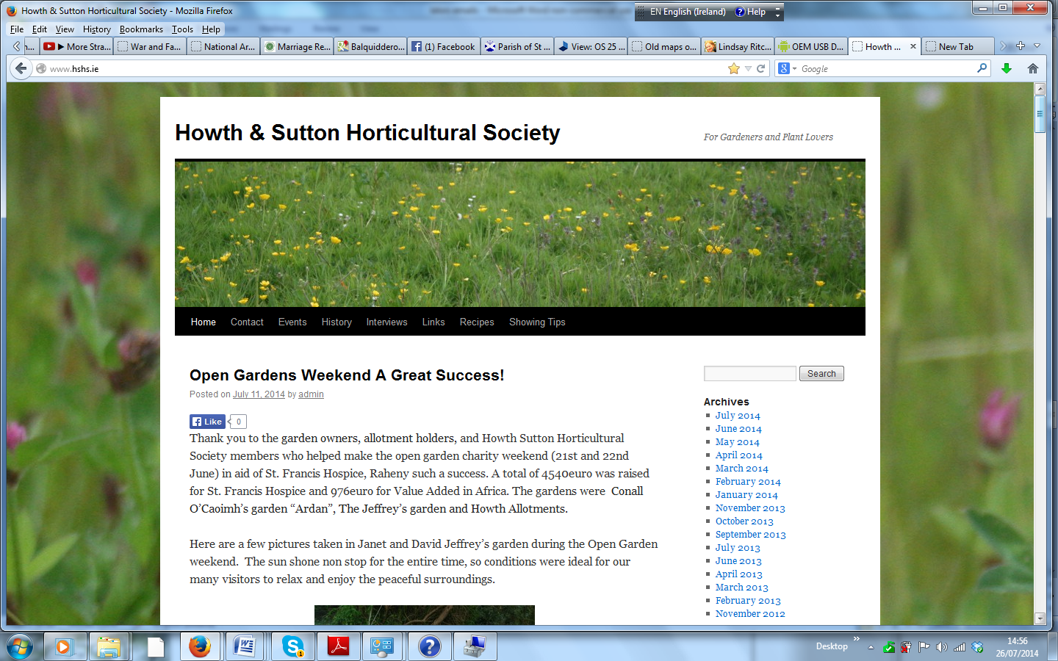

***www.hshs.ie***