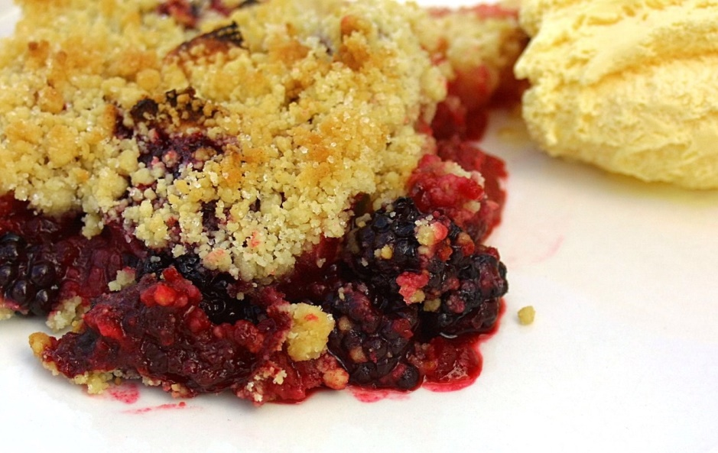
Robert’s Fruit Crumble

Filing Ingredients:
800g fruit (2/3 cooking apples, 1/3 blackberries...or any fruit of choice)
100g caster sugar
Crumble Topping
100g wholemeal flour
100g porridge oats
100g unsalted butter
60g caster sugar (more or less as preferred)
Method
- Preheat oven to 190°c/375°F (cooler for fan ovns)/Gas Mark 5
- Peel and core apples, quarter and cut into chunks. Wash and prepare other fruits accordingly.
- Put apples and other fruits into pan with sugar and 2 tablespoons of water, then cook over a low heat for 5 minutes to soften slightly, stirring occasionally, then tip into small ovenproof baking dish.
- Place the flour and oats in a bowl and mix well. Chop butter into small cubes and add this to the oats and flour. Mix and rub in with your fingertips until it resembles an even crumb mixture.
- Add remainder of the sugar and mix through, then cover the fruit crumble mixture.
- Bake for around 20 minutes or until golden and cooked through.
- Place dish under grill for last 1-2 minutes of cooking to brown the top taking care not to let it burn.
- Enjoy served warm or cold with custard or ice cream or cream

